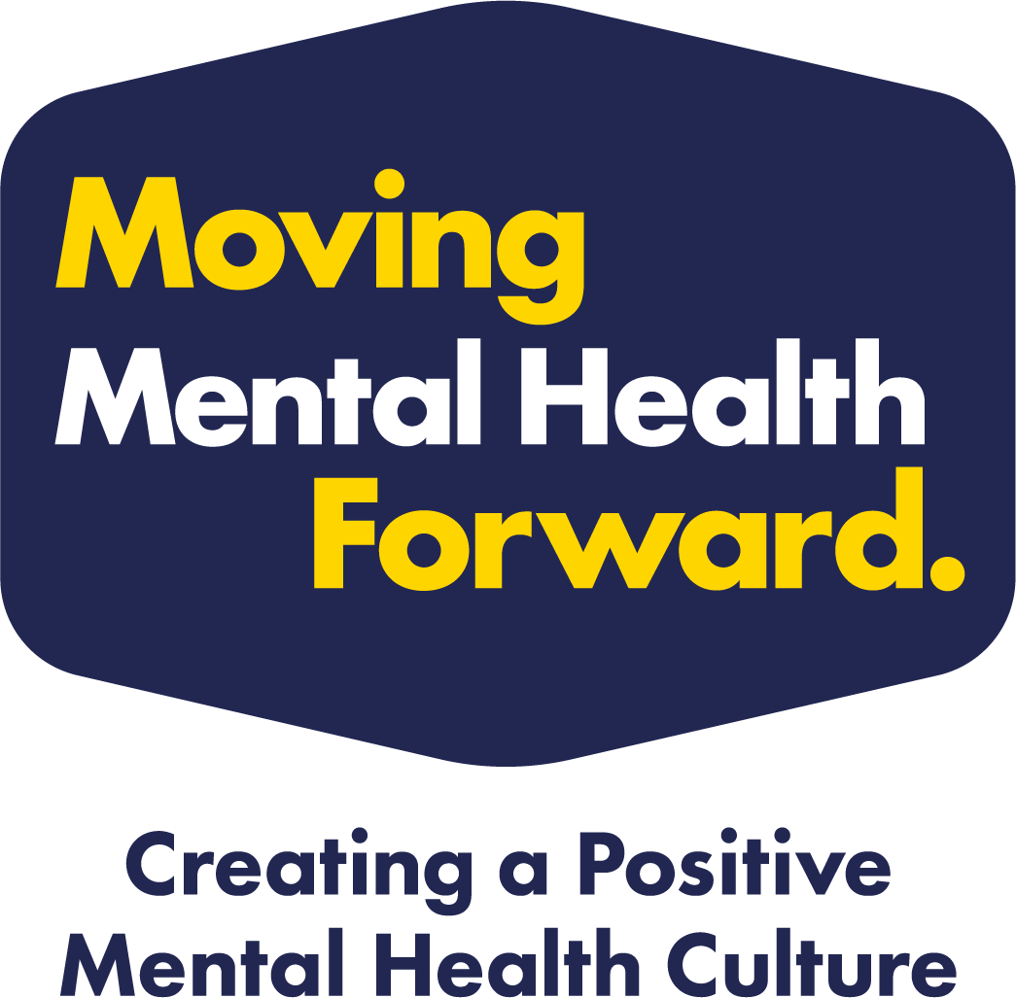

Activation Grant – Application Form

The activation grant is available to help you promote, advocate and activate your organisation, group or club and to support the positive culture with the people in and around you.

Organisations, groups and clubs can apply for grants of up to £2,000 to fund a variety of different ideas, projects and campaigns - all to help develop a positive mental health culture. For projects larger than this amount we can support you with accessing larger grant pots; please just get in touch for more information.

The application process is quick and easy to complete and is specifically created for organisations, groups and clubs that want to embed the Moving Mental Health Forward principles into their environment.

Completed applications needs to be sent to sportandactiverecreation@barnsley.gov.uk. If the application is successful, we will expect you to keep a track of how you spend the funding with evidence showing the items paid for.

Who can apply?

You should:
- Have a valid constitution.
- Have a bank account in the club name.
- Be Barnsley based i.e. meet, train and compete within Barnsley. If your club is situated at the boundary with another council area, Barnsley residents must make up at least 75% of your organisation, group or club customer base or membership.
- Be an organisation, group or club that is part of the Moving Mental Health Forward Network.

What we will fund?
- Training, events.
- Awareness raising, promotional items – banners etc.
- Media and communications.
- New targeted sessions.
- Great ideas!

What we won’t fund?
- Retrospective purchases (proof of expenditure must be provided within two months of purchase).

Examples of how the grant can be used
- To host a community event to raise awareness of mental health
- To start up a new session focused on supporting people’s mental health
- To purchase a ‘talking bench’ or a similar safe place to talk openly
- To attend mental health training and courses

MOVING MENTAL HEALTH FORWARD

APPLICATION FORM

Organisation/group/club name:
Name and position held within the organisation/group/club:

Telephone:

Contact email:
Address for correspondence:

Bank Account Name:
Sort code: |  | Account Number:
Estimate how many direct and indirect people are involved with your organisation, group or club?
(This could be participants, volunteers, supporters, parents, staff etc.)
From the number given above, estimate for each section below the % of that number that are in the follow:
Gender split (100%) | Female: |  |  |  | Male: |  |  |  |  | Other:
Age breakdown (100%) | 0-4: |  |  | 5-17: |  | 18-25: |  | 25-64: |  |  | 65+:
People with a disability (100%) |  |  | People without a disability |  |  |  |  |  | Not known

- We would like you to tell us about your project idea. What is it you would like to do?

- How will your project help your organisation, group or club to create and support a positive mental health culture?

- What do you think will be the impact of your project on the people in and around your organisation, group or club?

- Will you be working with any partners or require any support from outside of your organisation, group or club?

- Is there any support or resources that would help to develop a positive mental health culture within your club/organisation? (i.e. Training, infographics etc)

Breakdown of your costs:

Item | Description | Cost
TOTAL AMOUNT REQUESTED:

Monitoring

The organisation, group or club will be required to complete a short monitoring survey on how you have used the activation grant, the impact and demonstrate how you have helped to Move Mental Health Forward.

Declaration

When you have completed the application, please sign this declaration and return the completed form to sportandactiverecreation@barnsley.gov.uk.

To the best of my knowledge the information I have provided on this application form is correct. If Barnsley Metropolitan Borough Council agrees to make a small grant, this will be used exclusively for the purposes described.

Moving Mental Health Forward Network

Successful clubs/organisations receiving a grant are expected to become an active member of the Moving Mental Health Forward Network. If you do NOT want to become part of the network, please mark a cross in the box.

Privacy Notice

By signing this form, the applicant agrees to the information gathered to be stored by Barnsley Metropolitan Borough Council.

Signed:
(Typed name is accepted)

Date:

